

**Mushroom Classification**

# (Machine Learning)

Architecture Document

# Project Member:

1. Dipans Verma

INeuron.ai

### Introduction:

* + What is architecture Design?

### Architecture Design (AD) aims to give the internal design of

the actual program code for the “Mushroom classification”.

### AD describes the class diagrams with the methods and relation between classes and program specifications.It describes the modules so that the programmer can directly code the program from the document.

* + Scope

### Architecture Design(AD) is a component-level design process that follows a step-by-step refinement process.This process can be used for designing data structures,required software,architecture ,source code , and ultimately

,performance algorithms.Overall,the data organization may be defined during requirement analysis and then refined during data design work and the complete workflow

### Constraints

We predict the mushroom whether it is edible or poisonous from the given features asked to do input.

### Problem statement:

The Audubon Society Field Guide to North American Mushrooms contains descriptions of hypothetical samples corresponding to 23 species of gilled mushrooms in the Agaricus and Lepiota Family Mushroom (1981). Each species is labelled as either definitely edible, definitely poisonous, or maybe edible but not recommended. This last category was merged with the toxic category. The Guide asserts unequivocally that there is no simple rule for judging a mushroom's edibility, such as "leaflets three, leave it be" for

Poisonous Oak and Ivy. The main goal is to predict which mushroom is poisonous & which is edible.

* Dataset

The dataset includes categorical characteristics on 8,124 mushroom samples from various species of gilled

mushrooms. • The target variable assessed was a class distinction of 'edible' or 'poisonous'. • The explanatory variables covered a range of descriptive and visual characteristics on the structure of each observed mushroom

## such as, cap colour, odor, ring number and stalk shape.

### Architecture

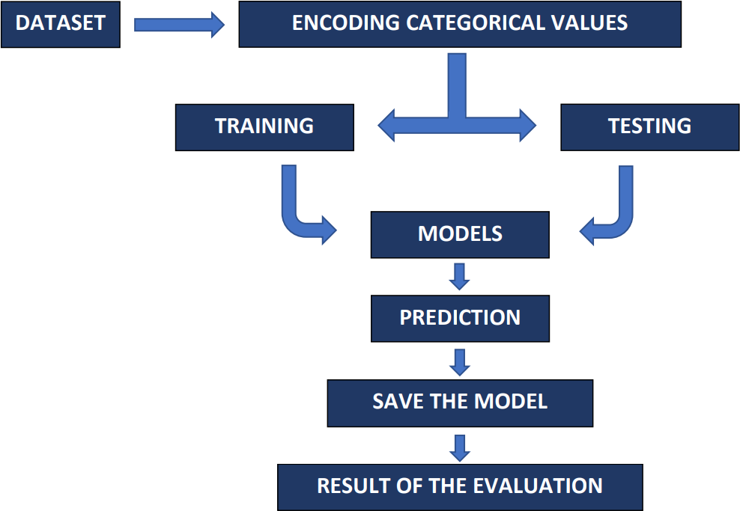

* + User Input/Output flow:

Give all the feature input for mushroom

Click on the

predict

Predict from Application

### Coclusion:

Our tuned classification models all performed really well with the dataset. Logistic Regression, which had a score of 99% would normally be a great choice but given that the model predicted false negatives which could be deadly, and that the other tested models performed perfectly, the other models are much better suited to classify mushrooms. Since our models performed so well, it was clear to us that they were able to identify specific traits that greatly influenced the classification of an edible versus poisonous mushroom. And that was exactly what we were hoping for!!

## Thanks